**Introduction**

Big Mountain Resort (BMR) current adult lift ticket price is $81 per day but based upon the features BMR has, modeling suggests the resort is currently underpriced. Data on 276 resorts through out the United States was used to create a pricing model based on features of other resorts and the cost of adult weekend ticket prices. BMR is currently the most expensive adult lift ticket in Montana, but when compared to a larger market segment, resorts with similar features can change approximately $95 per adult weekend ticket price.

**BMR Facilities Broad Market Comparison**

In the modeling process, many important features that affect pricing were identified. Resorts that had more of these features also had higher adult lift ticket prices. The distributions below visualize where BMR plots within these distributions. The vertical red dashed line in the distribution plots below is where BMR is plotting. The plots illustrate that BMR is plotting on the upper end of the important features that appear to be driving adult ticket prices according to the model.

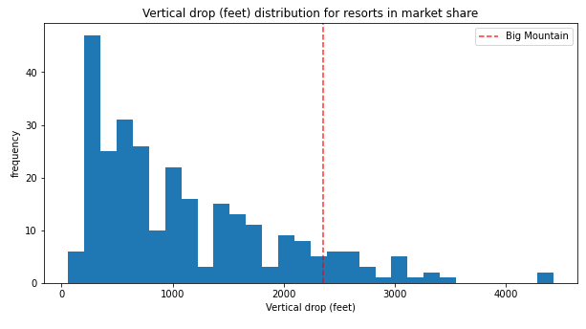 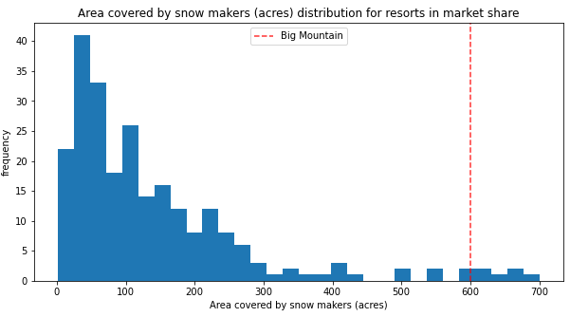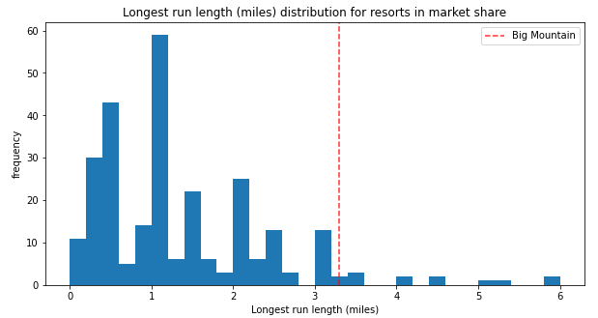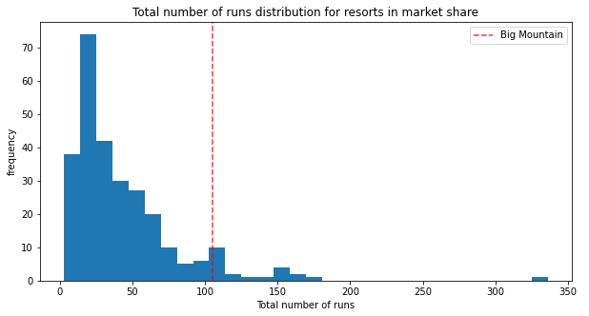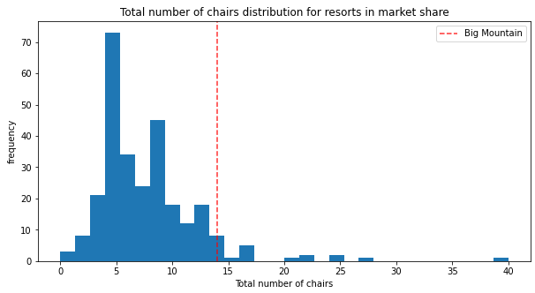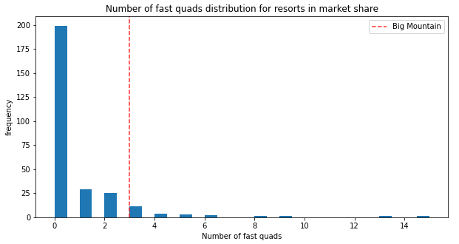

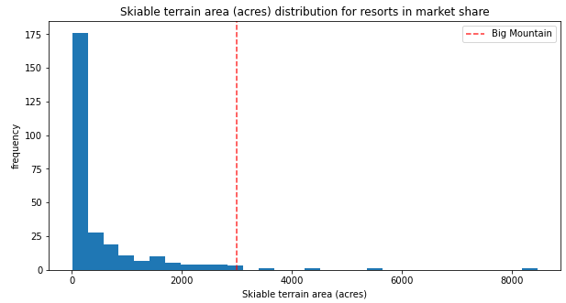

The data in the visualizations above are some of the important data driving the pricing model that was created. The distribution directly above shows that BMR lives up to its name, only 4 resorts in this broad market segment study have more skiable terrain than BMR.

**Model Results and Opportunities**

Based upon the adult weekend ticket prices and features of the 276 resorts in this broad market study, it appears BMR can charge $95 per adult weekend ticket. The model identified the important drivers that appear to be driving ticket prices and this information can also be used to identify investment opportunities or implement cost reduction initiatives. For example, the model suggests adding additional lifts to access more vertical could result in $1.5 MM in additional profit. The model also identified a potential opportunity of closing a limited number of runs would have a minor impact on revenue that could be offset by reductional in operational costs.

**Summary**

BMR has many features that skiers are willing to pay for. By looking at a broader market segment, BMR does appear to have many features skiers would pay a premium to access. The resulting model suggests the adult pricing can be increased from the current price of $81 to $95 per ticket.